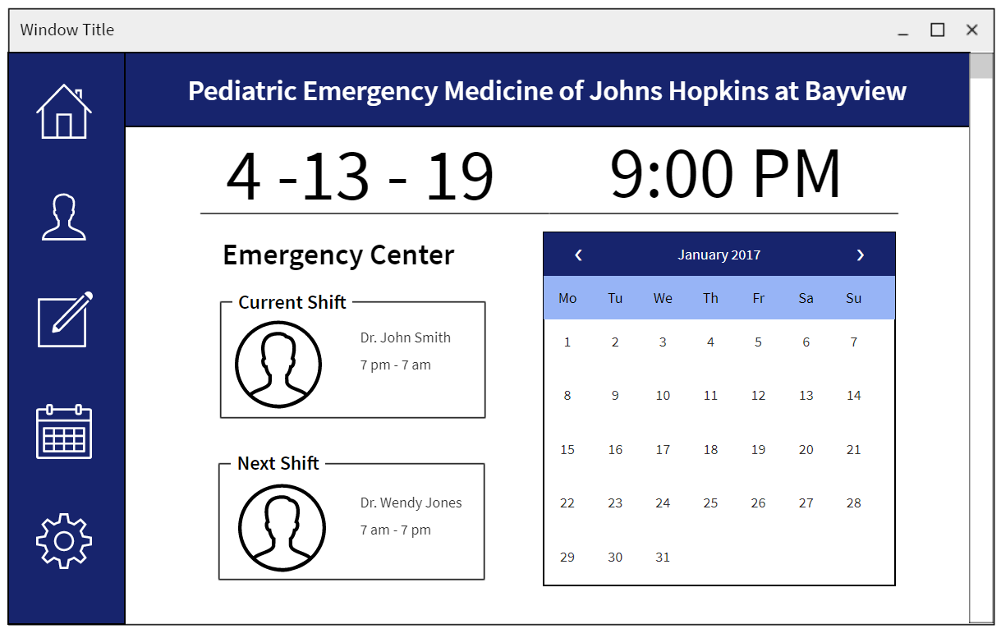

Home Screen [First thing you see when you open the program]

Home Button

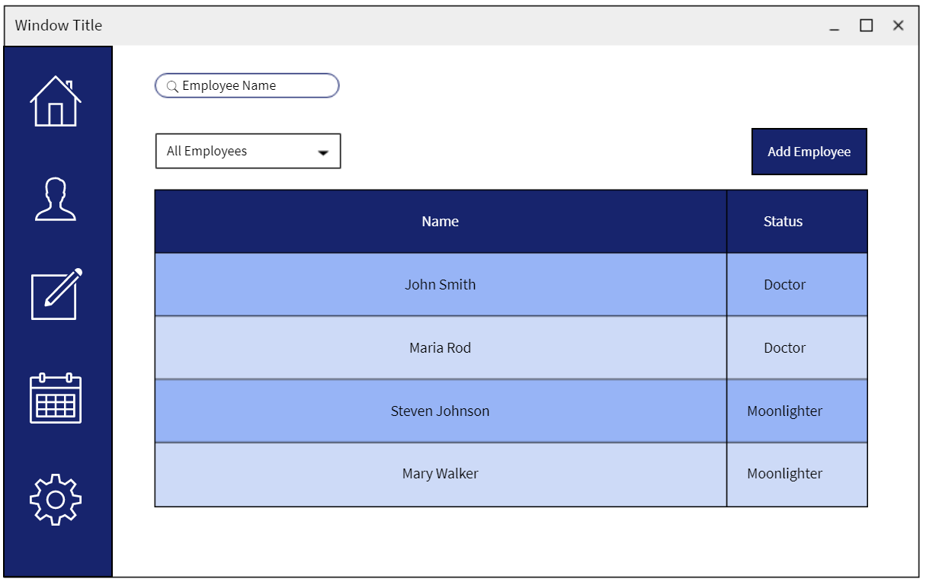

Profile Search

Profile Button

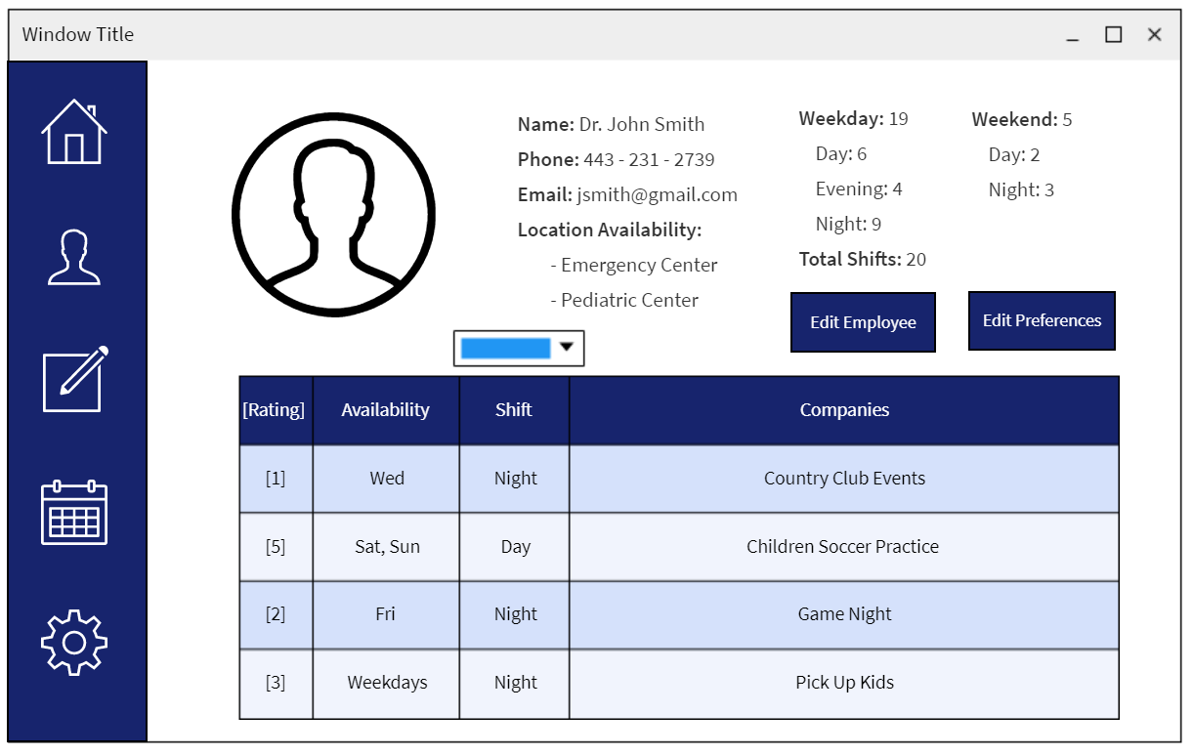Individual Profile  
Profile Button -> Select a specific employee

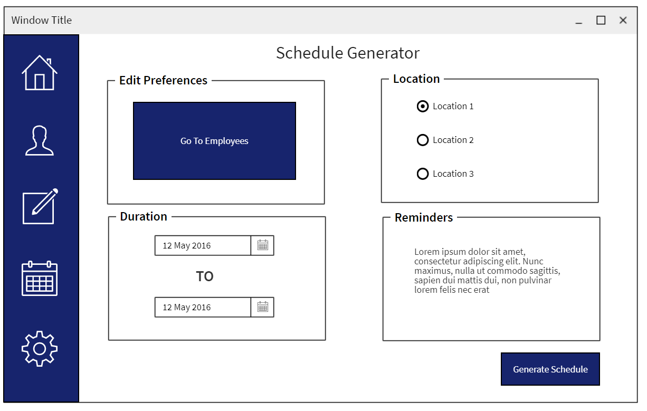

Schedule Generator

Schedule Builder

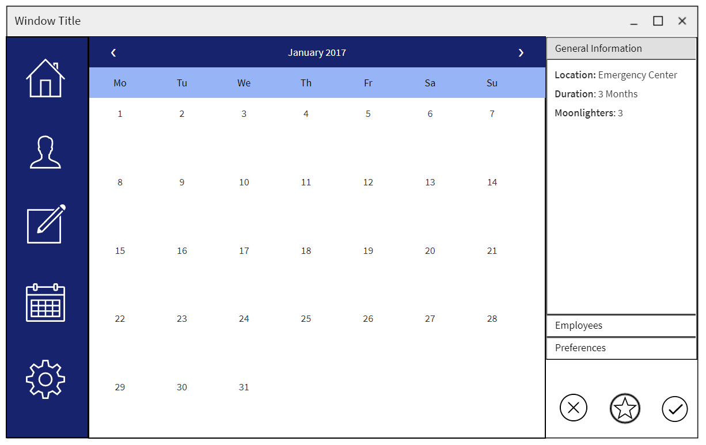

Preview Schedule  
Schedule Builder -> Generate Schedule

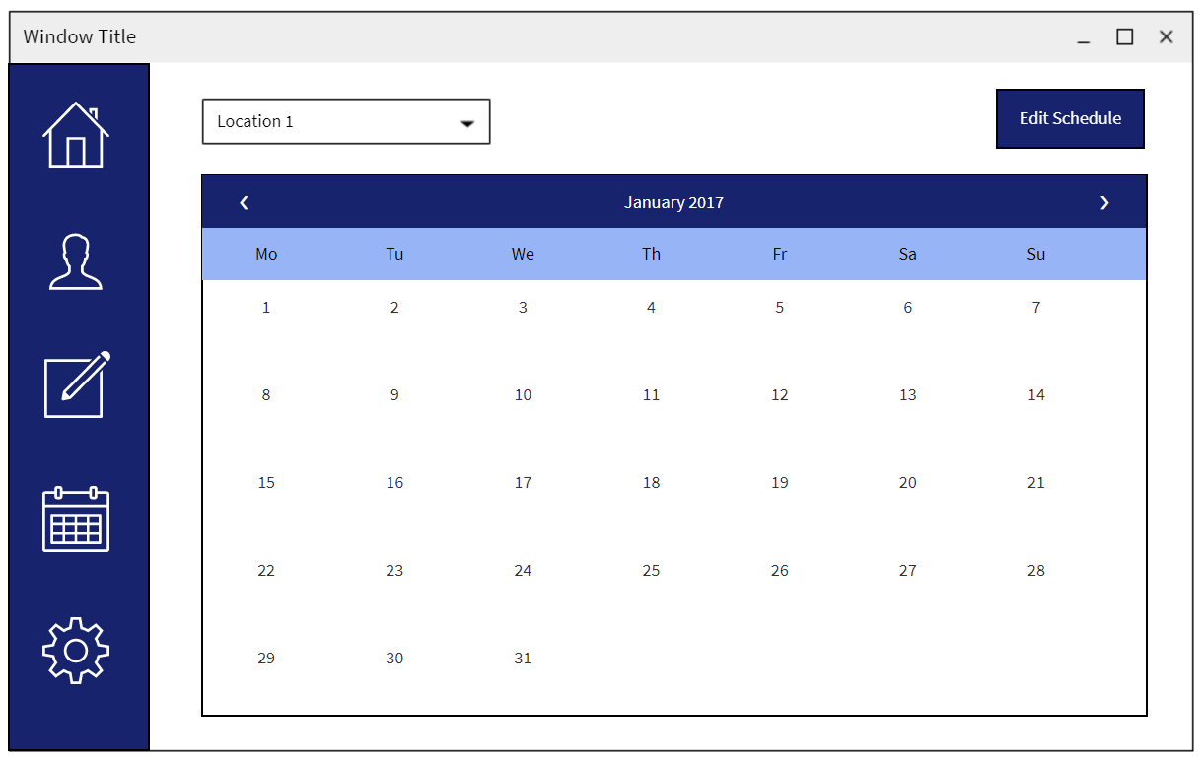

View Schedule

View Schedule Button